**Circuit and System-I**

**LAB # 03**



**Spring 2022**

Submitted by: **Ali Asghar**

Registration No.: **21PWCSE2059**

Class Section: **C**

“On my honor, as student of University of Engineering and Technology, I have neither given nor received unauthorized assistance on this academic work.”

Student Signature: ______________

Submitted to:

**Engr. Faiz Ullah**

21 April, 2022

Department of Computer Systems Engineering

**ASSESSMENT RUBRICS LAB # 03**

**Verification of Ohm’s law Using PSPICE**

|  |  |  |  |  |
| --- | --- | --- | --- | --- |
| **LAB REPORT ASSESSMENT** | | | | |
| **Criteria** | **Excellent** | **Average** | **Nil** | **Marks Obtained** |
| 1. **Objectives of Lab** | All objectives of lab are properly covered  [Marks 1] | Objectives of lab are partially covered  [Marks 0.5] | Objectives of lab are not shown  [Marks 0] |  |
| 1. **Ohm’s Law and Mathematical Expression.** | Correct definition of Ohm’s law, mathematical expression and circuit diagram is shown.  [Marks 1] | Correct statement of Ohm’s law and no mathematical expression and circuit diagram with no labels.  [Marks 0.5] | No definition, mathematical expression and circuit diagram is shown  [Marks 0] |  |
| 1. **PSPICE and its Procedure.** | Elaborate PSPICE software and its procedure for designing circuit.  [Marks 2] | PSPICE is not defined while its procedure is not properly discussed  [Marks 1] | No Definition or procedure.  [Marks 0] |  |
| 1. **Circuit Diagram in PSPICE.** | Circuit diagrams for all cases of varying resisters and source voltages are shown with titles and labels in PSPICE.  [Marks 2] | Some of the cases of varying resisters and source voltages are shown with no titles and labels in PSPICE  [Marks 1] | No circuit diagrams are shown  [Marks 0] |  |
| 1. **Observations & Calculations** | All experimental results are completely shown in form of table.  [Marks 2] | Experimental results are partially shown and some of the observations are missing.  [Marks 1] | No experimental results are shown  [Marks 0] |  |
| 1. **Graphs** | Graphs from experimental results of Ohm’s law are shown with labels. [Marks 1] | Graphs from experimental results of Ohm’s law are shown with no labels . [Marks 0.5] | No graphs are shown  [Marks 0] |  |
| 1. **Conclusion** | Conclusion about experimental results is properly explained and satisfactory. [Marks 1] | Conclusion about experimental results is not properly explained and satisfactory. [Marks 0.5] | No conclusion is shown  [Marks 0] |  |
| Total Marks Obtained:__________  Instructor Signature: ______________________ | | | | |
|  | | | | |

**Title:**

Verification of **OHM’s** law using PSPICE

**Objectives** :

* To find current in the wire using PSPICE software.
* We will be able to use PSPICE.
* We will be able to use OHMs Law.

**Ohms law:**

**Definition**:

Ohm’s law states that the current in an electric circuit is proportional to the applied voltage and inversely proportional to its resistance*.*

Mathematical Expression:

V = IR

**Circuit Diagram :**

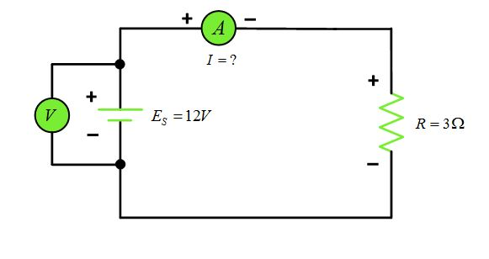

**PSPICE**

**Intoduction:**

**PSpice** is a SPICE analog circuit and digital logic simulation software that runs on personal computers, hence the first letter "P" in its name. It was developed by MicroSim and is used in electronic design automation. MicroSim was bought by OrCAD which was subsequently purchased by Cadence Design Systems. The name is an acronym for Personal Simulation Program with Integrated Circuit Emphasis. Today it has evolved into an analog mixed signal simulator.

OR

“PSPICE is a circuit analysis tool that allows the user to simulate a circuit and extract key voltages and currents.”

**STEPS**:

* Go to start menu and search for Schematics.
* Select “Menu Draw”. Get new parts.
* Then click the “Libraries” button (You will get a window named as Library Brower).
* Go to “Part Browser Basic”, input the device name in the “Part Name” or select it in the bottom catalog.
* Click “Place” button, then you can put the selected devices into you schematic.
* Connect the devices you have put onto your schematic, use menu “Draw Wire“, your cursor would change to be a pencil.
* Check your circuit carefully, compare it with the circuit in your Lab Pak. Check the name and value of every device.
* Save your schematic.
* Use the menu “Analysis Setup” to set up the simulation condition.
* Use the menu “Analysis Simulation”.

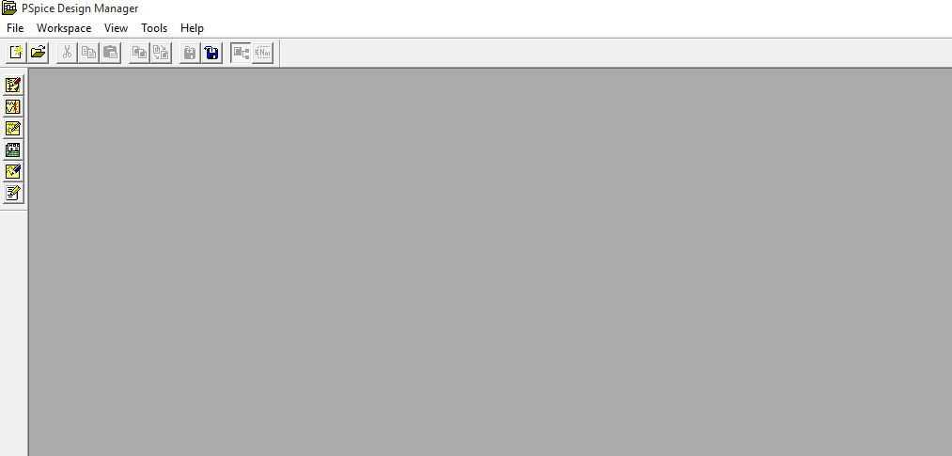

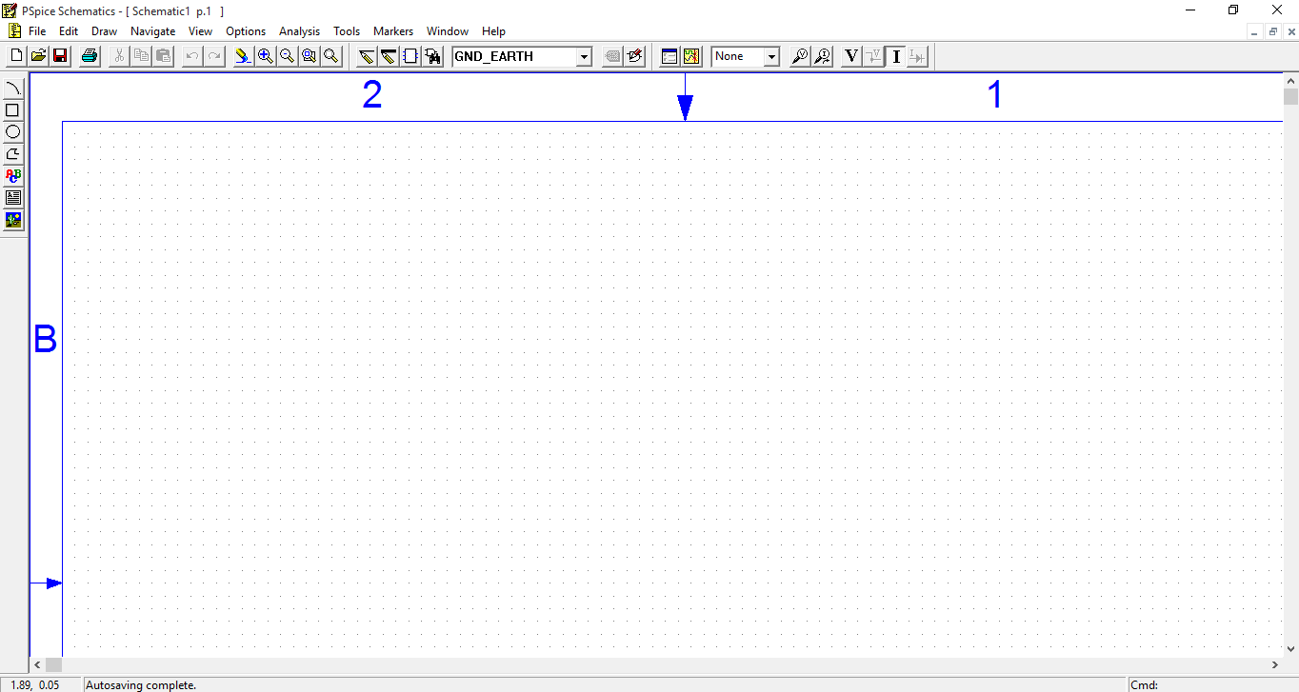

**Case 1:**

Voltage of **5v** and resistance of **16kΩ**. The current in this circuit is **312.5 µA.**

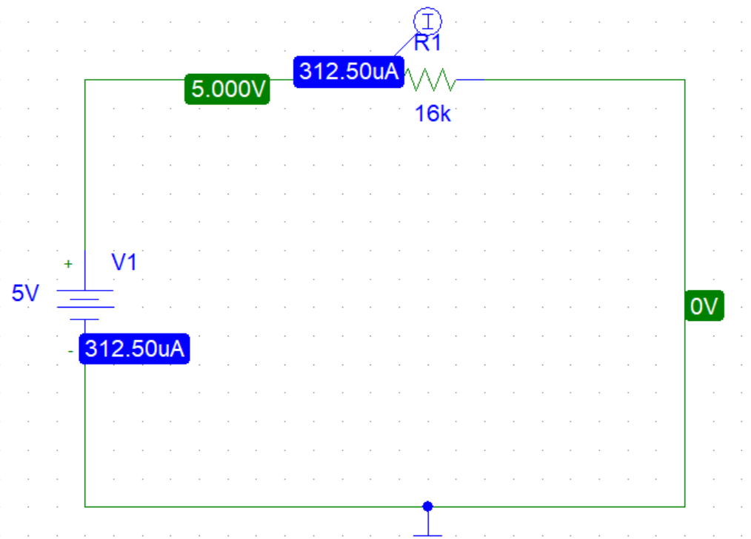

**Case 2:**

Voltage of **10v** and resistance of **16kΩ**.The current in this circuit is **625.00 µA**.

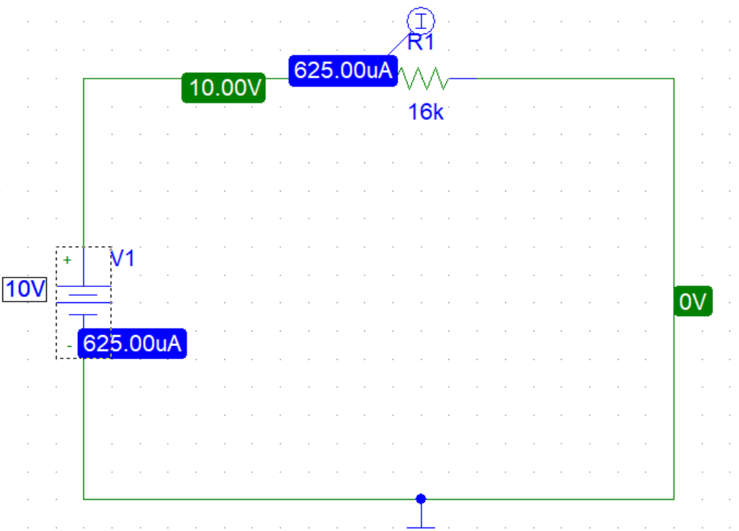

**Case 3:**

Voltage of **15v** and resistance of **16kΩ**.The current in this circuit is **937.50 µA**.

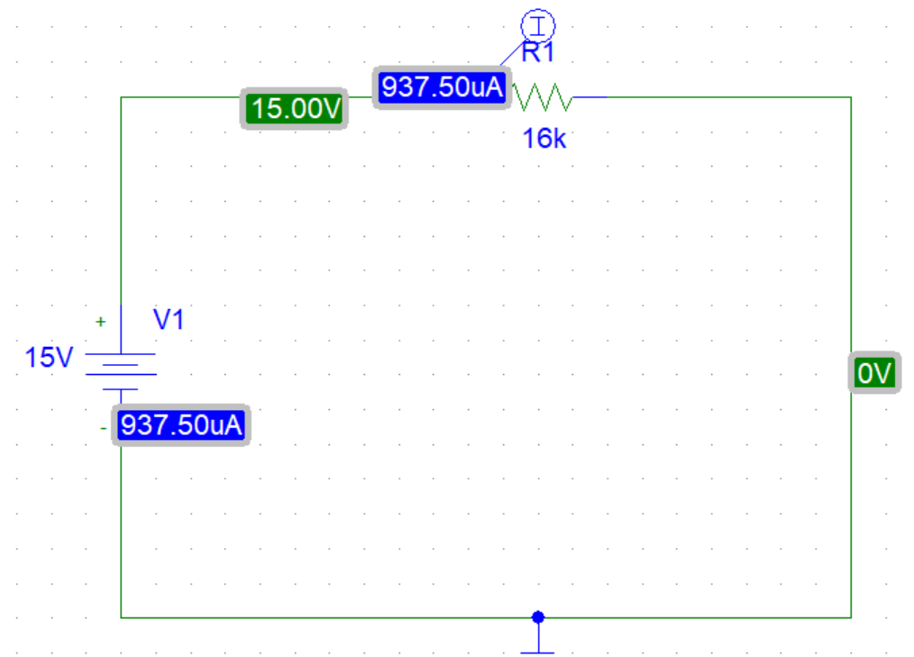

**Case 4:**

Voltage of **20v** and resistance of **16kΩ**.The current in this circuit is **1.250mA**.

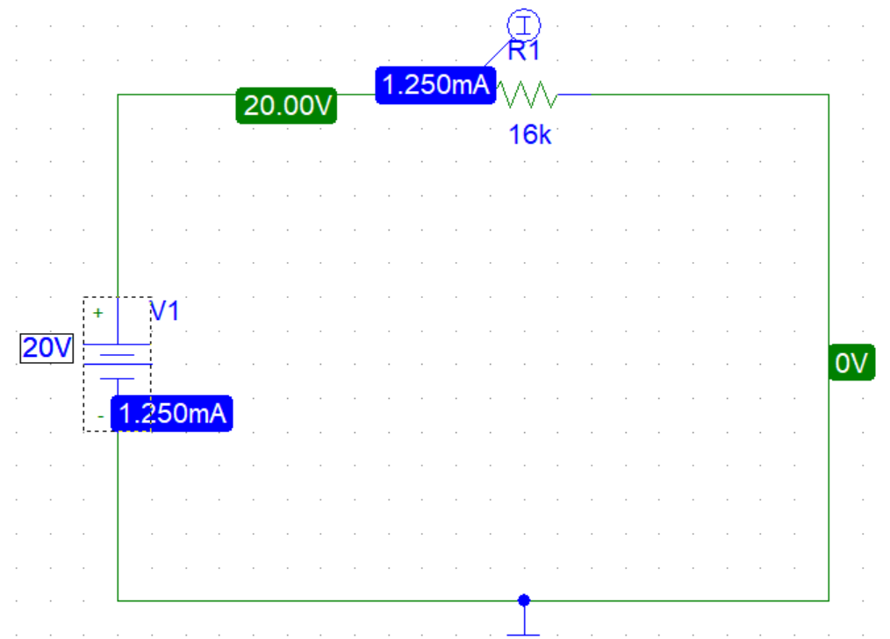

**Case 5:**

Voltage of **25v** and resistance of **16kΩ**.The current in this circuit is **1.563 mA**.

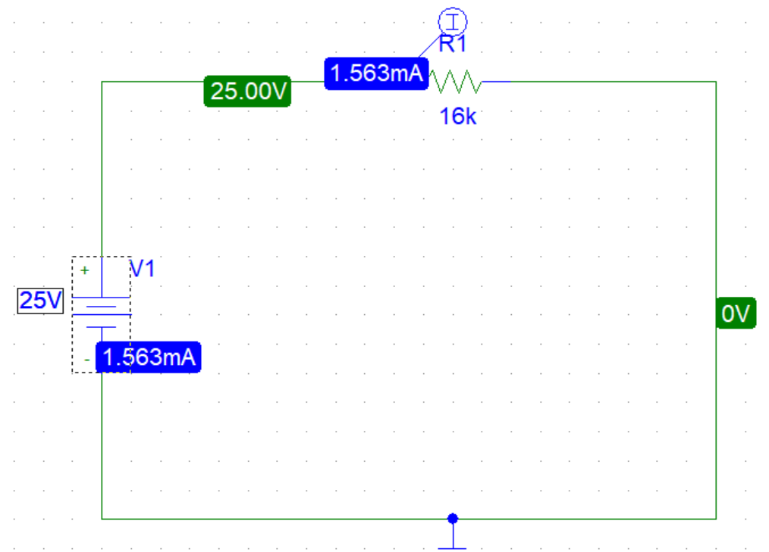

**Case 6:**

Voltage of **30v** and resistance of **16kΩ**.The current in this circuit is **1.875mA**.

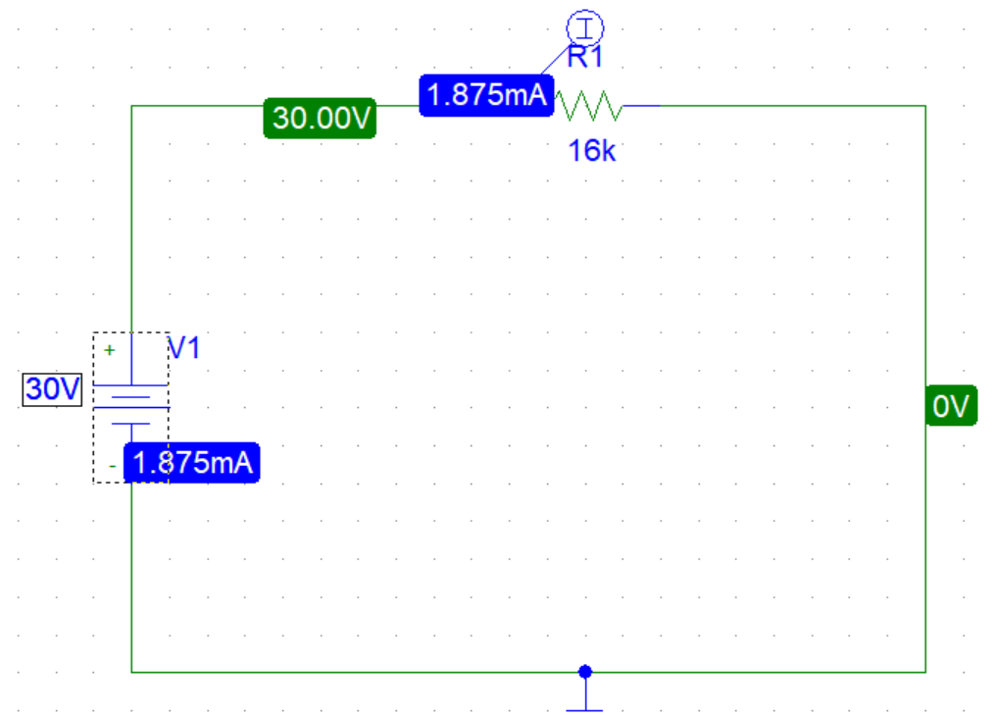

**OBSERVATION:**

|  |  |  |  |
| --- | --- | --- | --- |
| **S.No** | **Voltage**  **(Volts)** | **Resistance**  **(Ohms)** | **Current**  **(Amperes)** |
| **1** | **5 V** | **16k Ω** | **312.5 µA** |
| **2** | **10 V** | **16k Ω** | **625.00 µA** |
| **3** | **15 V** | **16k Ω** | **937.50 µA** |
| **4** | **20 V** | **16k Ω** | **1250 µA** |
| **5** | **25 V** | **16k Ω** | **1563 µA** |
| **6** | **30 V** | **16k Ω** | **1875 µA** |

**GRAPH BETWEEN VOLTAGE AND CURRENT:**

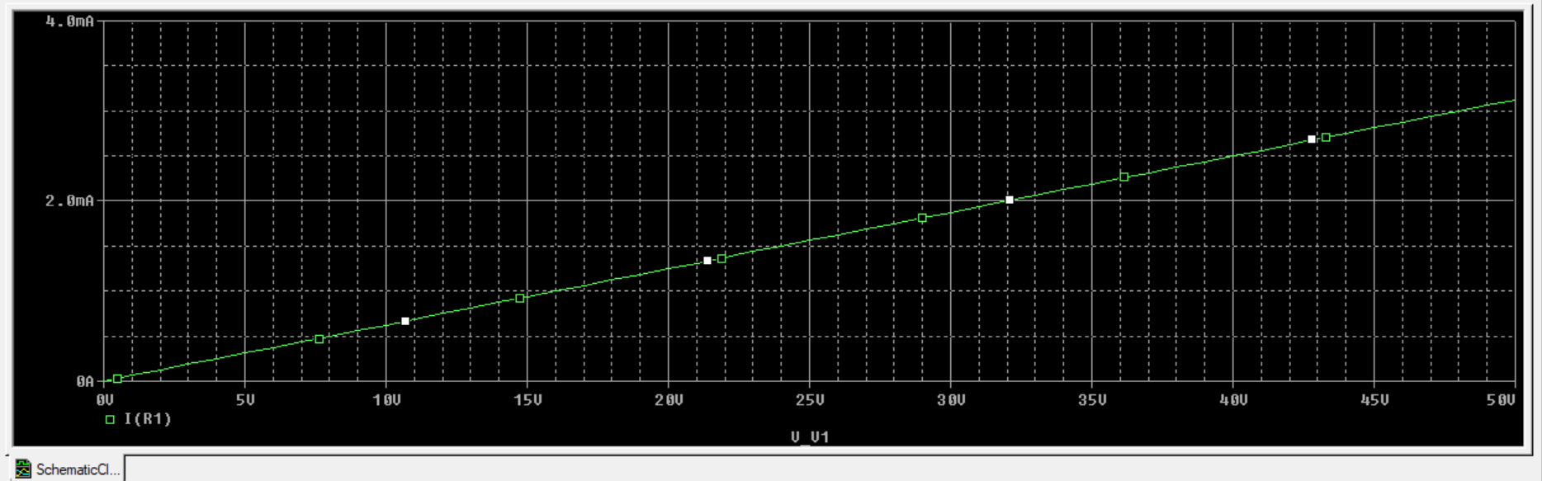

**Conclusion:**

From this we concluded that voltage is directly proportional to the current when the resistance is constant. Or if we keep any one of these constant, other two are proportional.